Course 12 Specialist Test 3 & Investigation 2

Test mark ______/24 Investigation mark ______/14

Student name: ________________ Teacher name: ________________

Task type: Response/Investigation

Time allowed for this task: 45 mins

Number of questions: 6 questions Test/ 1 question Inv

Materials required: Calculator with CAS capability (to be provided by the student)

Standard items: Pens (blue/black preferred), pencils (including coloured), sharpener, correction fluid/tape, eraser, ruler, highlighters

Special items: Drawing instruments, templates, notes on one unfolded sheet of
A4 paper, and up to three calculators approved for use in the WACE examinations

Marks available: 24 marks Test/ 14 marks Inv

Task weighting: Test 6 % Inv 8%

Formula sheet provided: Yes

Note: All part questions worth more than 2 marks require working to obtain full marks.

This first section will be recorded as test 3 in the assessment schedule.
Students decide how much time they will spend on each section, recommended 30 mins test & 15 mins Inv.

Q1 (3 marks)
Determine the equation of the tangent to at the point .

Q2 (3 marks)
If determine an expression for in terms of .

Q3 (2 & 3 = 5 marks)
If and determine:
- in terms of .

- in terms of . (No need to simplify)

Q4 (4 marks)
Consider a metal sphere where the volume was measured and found to have an error of 5%. Use the increments formula to determine the approximate percentage error in the radius.

Q5 (4 marks)
Consider a triangle with angle radians and opposite side length cm, see diagram below. If the angle is changing at a rate of 3 radians/second, determine the exact time rate of change of when .

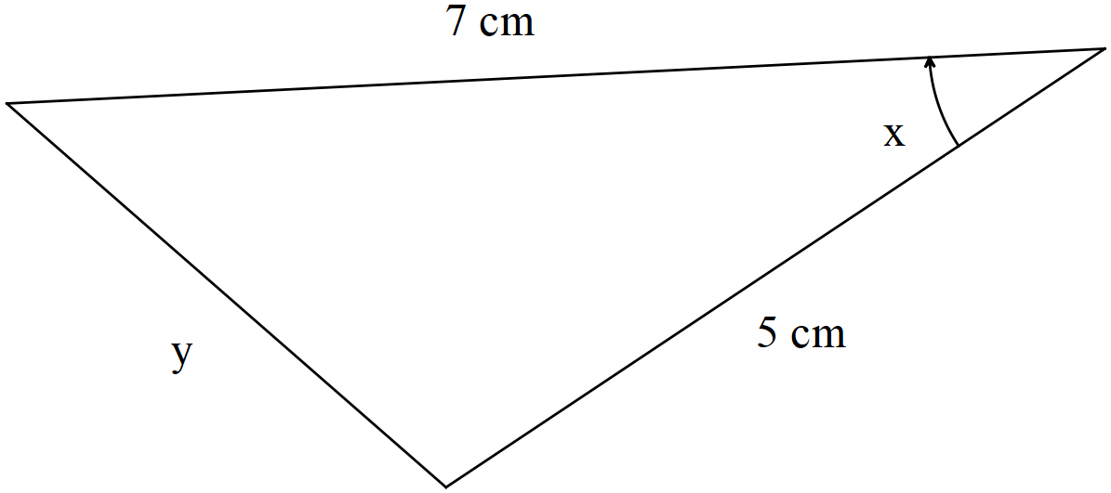

Q6 (5 marks)

Consider a car moving at metres/second towards a brick wall. On top of the car is a rotating light moving at an angular speed of radians/second. When the light ray hits the wall a spot of light can be seen moving along the line of the wall. Determine the speed of this dot of light on the wall when the light on top of the car is 12 m from the wall and the spot of light 5 m from the central point as shown on the diagram below.

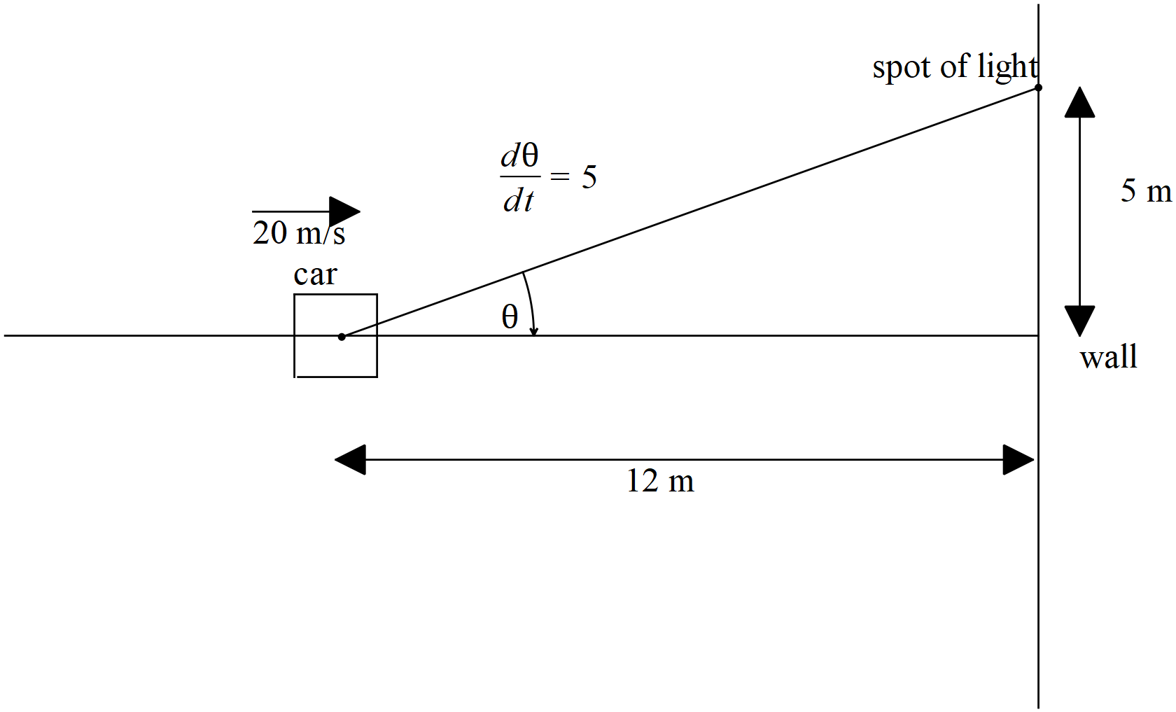

Investigation section.

Q1 (3, 3, 4 & 4 = 14 marks)
Differentiate the following using logarithmic differentiation. Show all steps in this method.

